**PART B – Micro-Project Report**

**Title: Employee Management System**

### 1.0 Rationale

### An employee management system is a software application that helps organizations manage employee-related activities, such as recruitment, onboarding, performance management, training and development, and employee benefits administration. The system provides a centralized platform for managing and tracking employee data.

In summary, an employee management system is an essential tool for organizations to manage and track employee-related activities efficiently, accurately, and in compliance with regulations. It also enhances employee engagement and provides valuable insights for decision-making, leading to a more effective and productive workforce.

### 2.0 Course Outcomes Addressed

a)Apply project management and quality assurance principles in software development.

b)Select suitable process model for software development.

c)Prepare software requirement specification

d)Use software modelling to create data designs

e)Apply project management and quality assurance principles in software development

### 3.0 Literature Review

"Design and implementation of cloud-based employee management system" by M. H. F. Lutfi et al. (2021): This paper presents the design and implementation of a cloud-based employee management system. The system is designed to manage employee information, attendance, and leave. The authors used Microsoft Azure for the system implementation.

"A comparative study of employee management systems" by S. R. Bhattacharjee and S. Sen (2020): This paper presents a comparative study of different employee management systems. The authors compared the features, advantages, and disadvantages of four different systems, namely SAP SuccessFactors, Workday, BambooHR, and ADP Workforce Now.

"Implementation of employee management system using biometric technology" by O. O. Olusola et al. (2019): This paper presents the implementation of an employee management system using biometric technology. The system uses fingerprint scanning to track employee attendance and generate reports. The authors used Python and OpenCV for the system implementation.

**4.0 Actual Methodology Used :**

### Problem Definition

Employee Management System manages employee details. Every organisation whether government or private uses an information system to store data of their staff. However in India, it is found that that many small scale industries use pen and paper to keep a record. However many advanced software are available that can this work but they all are costly for these low level industries. This software discusses making a software for solving a problem for them in a cheaper cost with basic functionality. This software consists of a program on one hand and handling records of employee. This software performs basic operations of inserting, updating, deleting, search record and display records of employees.The system will centralize the management system and will provide different option to make it more accessible. This project will automate basic record management features to increase speed of management system. While the development of the system will be simple and allow for the expansion of the project in the future as per requirement.

**Functional Requirements:**

Functional requirements for an employee management system in software engineering may include the following:

* Employee Information Management: The system should be able to store and manage employee information such as personal information, employment history, job details, and contact information.
* Recruitment and Onboarding: The system should be able to manage the recruitment and onboarding process, including posting job openings, receiving and reviewing resumes, scheduling interviews, and onboarding new employees.
* Payroll and Benefits Administration: The system should be able to manage employee compensation and benefits, including calculating salaries, processing payroll, and managing benefits enrollment.
* Employee Self-Service: The system should be able to provide employees with self-service capabilities, allowing them to view and update their personal information, submit leave requests, view their attendance and performance records, and access company policies and procedures.
* Reporting and Analytics: The system should be able to generate reports and analytics on various employee-related metrics, including attendance, leave, performance, and training. The system should also allow users to create custom reports and dashboards.

### Non-Functional Requirements

Non-functional requirements for an employee management system in software engineering may include the following:

* Scalability: The system should be able to handle increasing numbers of employees and data without affecting system performance or response times.
* Availability: The system should be available and accessible to users at all times, with minimal downtime or maintenance periods.
* Reliability: The system should be reliable and able to operate without errors or system failures, with backups and disaster recovery processes in place.
* Performance: The system should be able to process large amounts of data quickly and efficiently, with fast response times and minimal latency.
* Usability: The system should be user-friendly and easy to navigate, with clear and intuitive interfaces and workflows.
* Accessibility: The system should be accessible to users with disabilities, with features such as screen readers and keyboard navigation.
* Security: The system should provide robust security measures to protect employee data and prevent unauthorized access, including encryption, access controls, and data backups.
* Compliance: The system should comply with relevant laws and regulations, such as data protection laws, employment laws, and privacy laws.

### References:

**Book-Name-**Software and Software engineeringEdition-7th

**Author Name-**Roger S. Pressman

<https://www.engppt.com>

**MODELLING**

### 1.Use Case diagram:

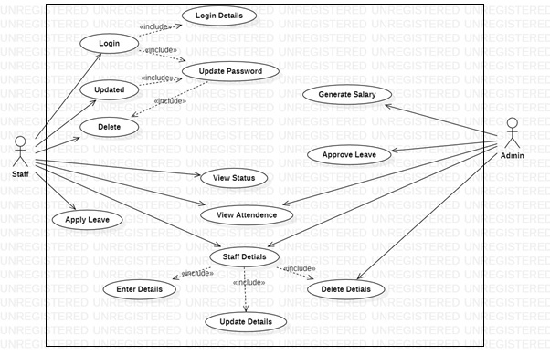

**2.ActivityDiagram:**

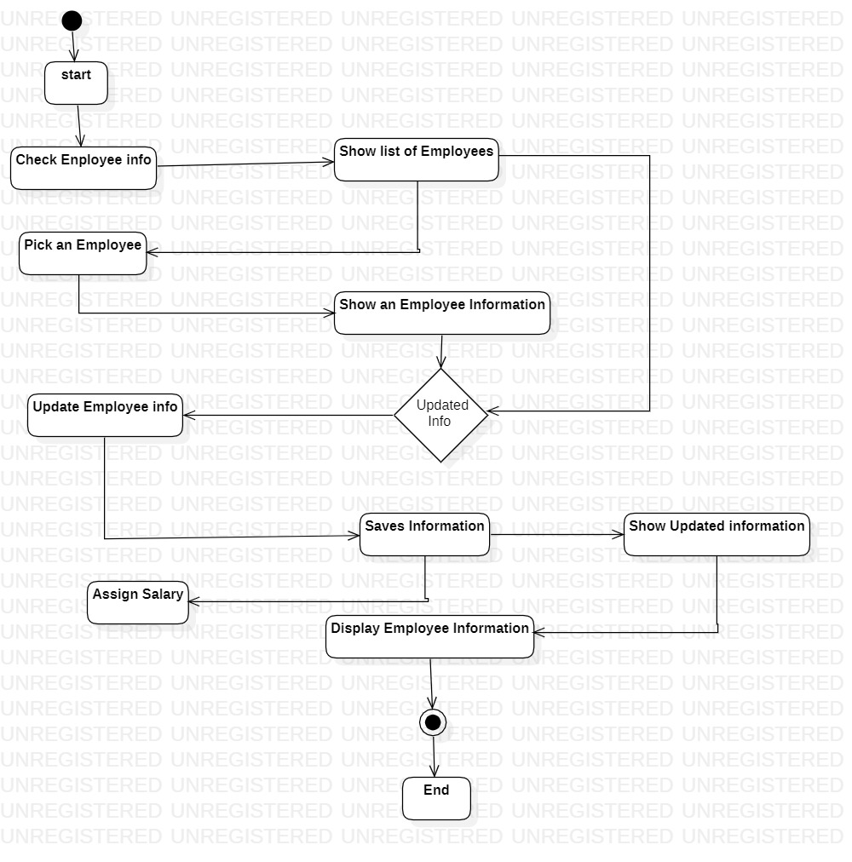

**3.ER Diagram:**

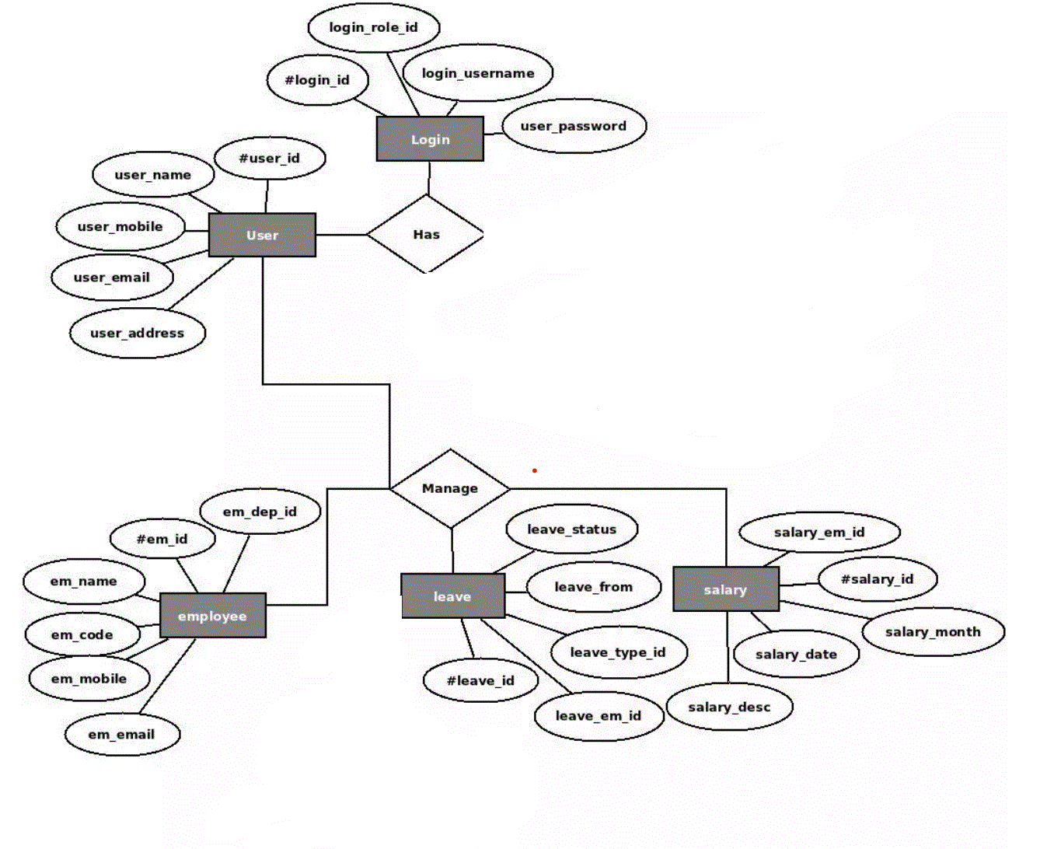

**4.Data Flow Diagram:**

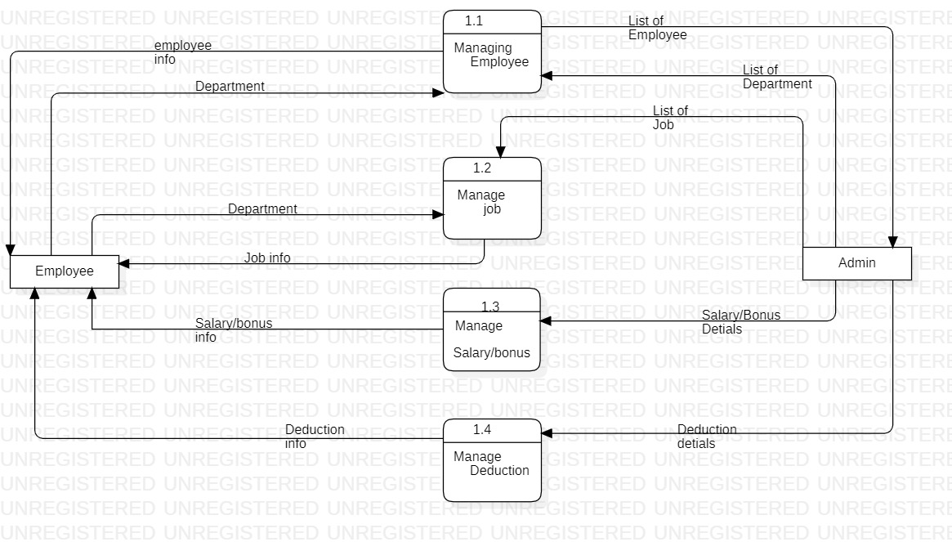

|  |  |  |  |  |
| --- | --- | --- | --- | --- |
| **Sr. No** | **Name of Resources** | **Specifications** | **Quantity** | **Remarks** |
| **1** | Hardware Computer systems | Intel core i5 10th Gen  8 GB Ram, 1TB SSD | 1 | **-** |
| **2** | Operating System | 64 bit operating system, windows 11 home single language | 1 | **-** |
| **3** | Software | Star UML | 1 | **-** |

**6.0 Skills Developed/Learning out of this Micro-Project**

* We developed technical skills.
* We developed project management skills.
* We developed Problem-solving skills.
* We developed collaboration skills

### 7.0 Applications of this Micro-Project

An employee management system (EMS) is a software application used by organizations to manage their employee-related information and processes. In the context of software engineering, an EMS can be used to streamline various HR-related tasks, such as recruitment, onboarding, performance evaluation, and employee development**.**